**Computer Network**

**Wireshark Lab 3a: UDP v8.0**

***Lecturer: Mr. Nguyễn Mạnh Thìn***

***Student: Trần Quốc Anh - 1852247***

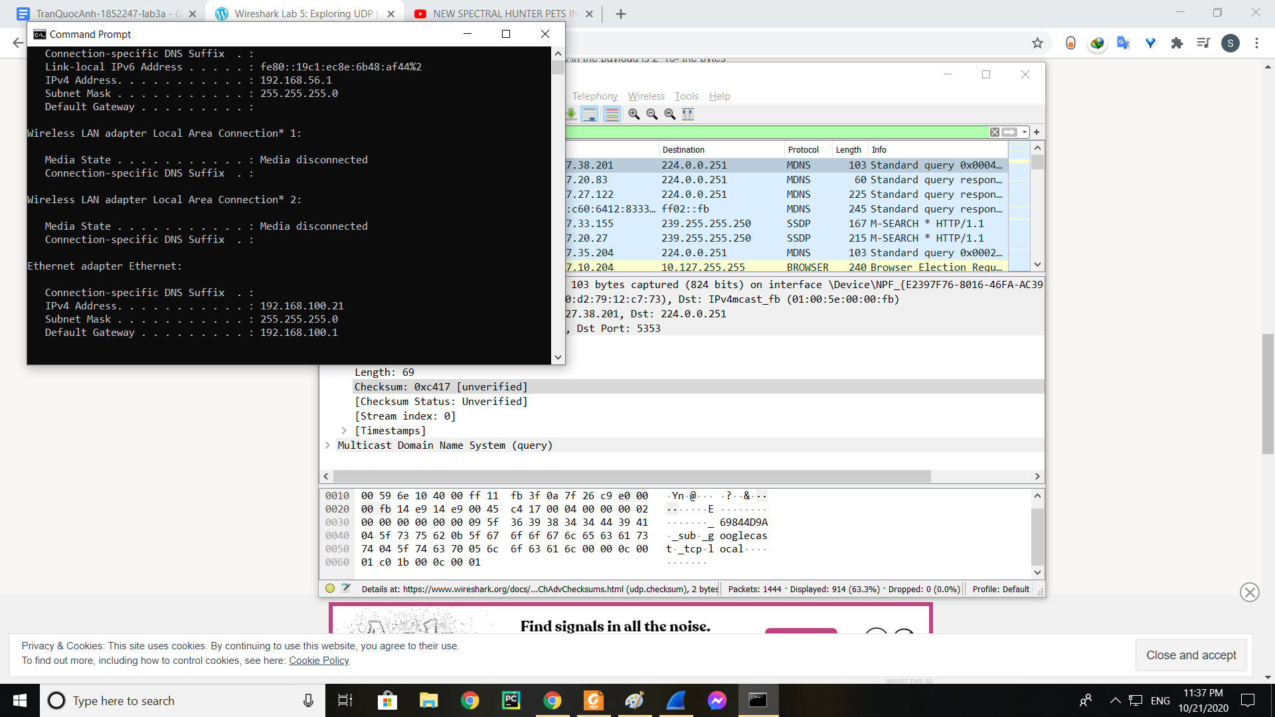

1. **Select one UDP packet from your trace. From this packet, determine how many fields there are in the UDP header. (You shouldn’t look in the textbook! Answer these questions directly from what you observe in the packet trace.) Name these fields.**

* There are 4 fields in the UDP header: Source Port, Destination Port, Length, Checksum

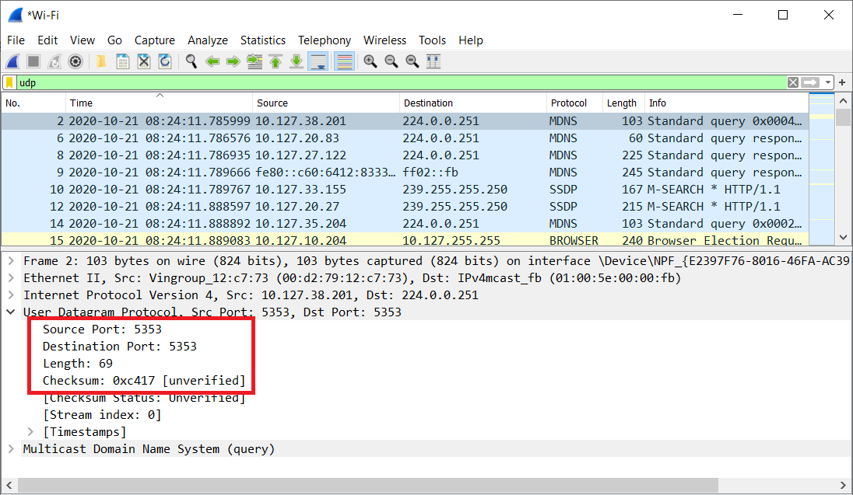

1. **By consulting the displayed information in Wireshark’s packet content field for this packet, determine the length (in bytes) of each of the UDP header fields.**

* Each of the UDP header fields is 2 bytes long

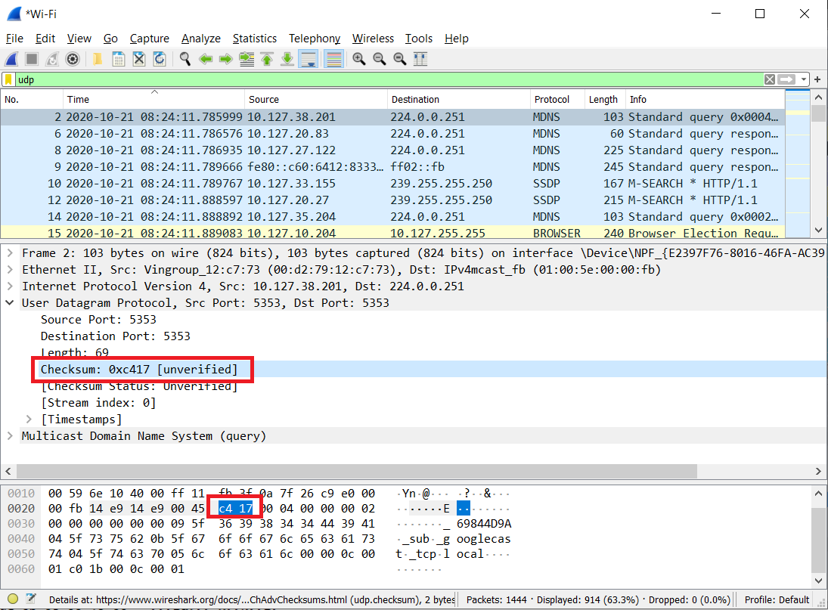

1. **The value in the Length field is the length of what? (You can consult the text for this answer)**

* The length field specifies the number of bytes in the UDP segment (header plus data).
* The value in the length field, in the example below it is 69, is the sum of the 8 header bytes and the remaining data bytes encapsulated in the packet.

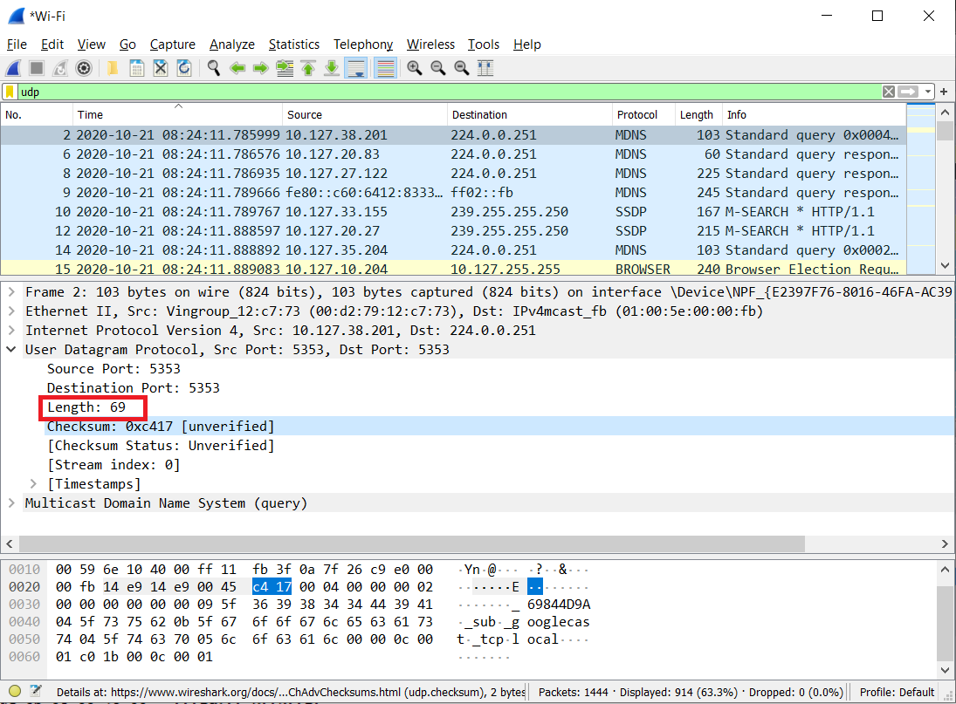

1. **What is the maximum number of bytes that can be included in a UDP payload?**

* The maximum number of bytes that can be included in a UDP payload is 2^16 – the bytes already being used by the header field (8). This gives 65535 bytes – 8 bytes = 65527 bytes.

1. **What is the largest possible source port number?**

* The largest possible source port number is (2^16 – 1) = 65535.

1. **What is the protocol number for UDP? Give your answer in both hexadecimal and decimal notation.**

* The protocol number in decimal for UDP is: 17
* The protocol number in hexadecimal for UDP is: 0x11

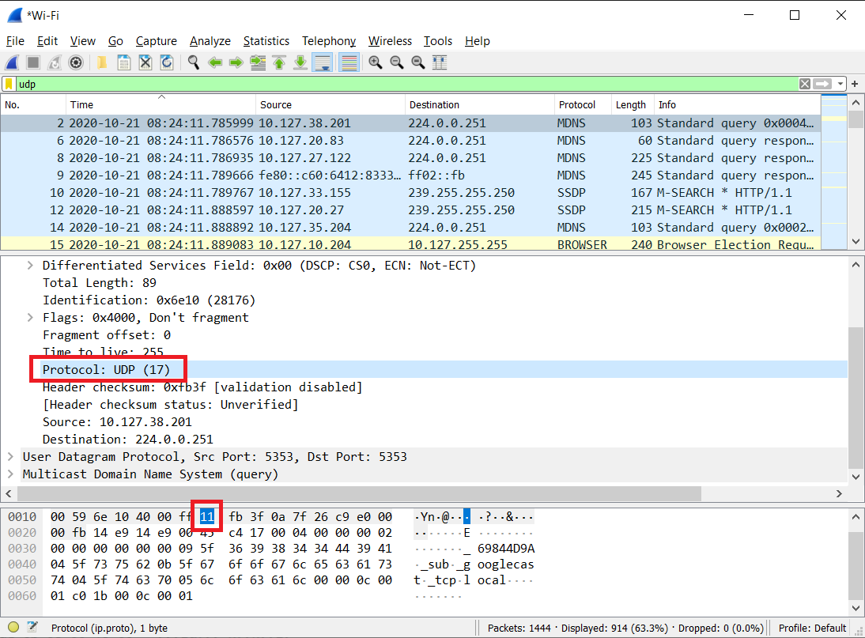

1. **Examine a pair of UDP packets in which your host sends the first UDP packet and the second UDP packet is a reply to this first UDP packet. Describe the relationship between the port numbers in the two packets.**

* The relationship between port numbers is that the source port on the send message is the destination port of the receive message. The destination port for the send message is also the source port for the receive message.

